Design Document

February 24th, 2026
Senior Project Spring 2026
AI Health and Fitness Application

Members:

Salim Aldakheel
Ken Kurian
Rohan Maisuria
Charan Saragadam
Trinity Varela
Edsson Zapata

Table of Contents
Architecture Overview 2
System Structure 3
Data Flow Architecture 3
Component Description 4
UML Class Diagram 5
UML Class Diagram Explanation 6
ER Diagram 7
UI mock-ups 8
Version Control Section 10

Architecture Overview

System Structure
The app will consist of a frontend layer, Python-based backend layer, database layer, and an AI recommendation engine. These layers will communicate through processes and APIs. The front end will send requests to the backend to be processed and stored.
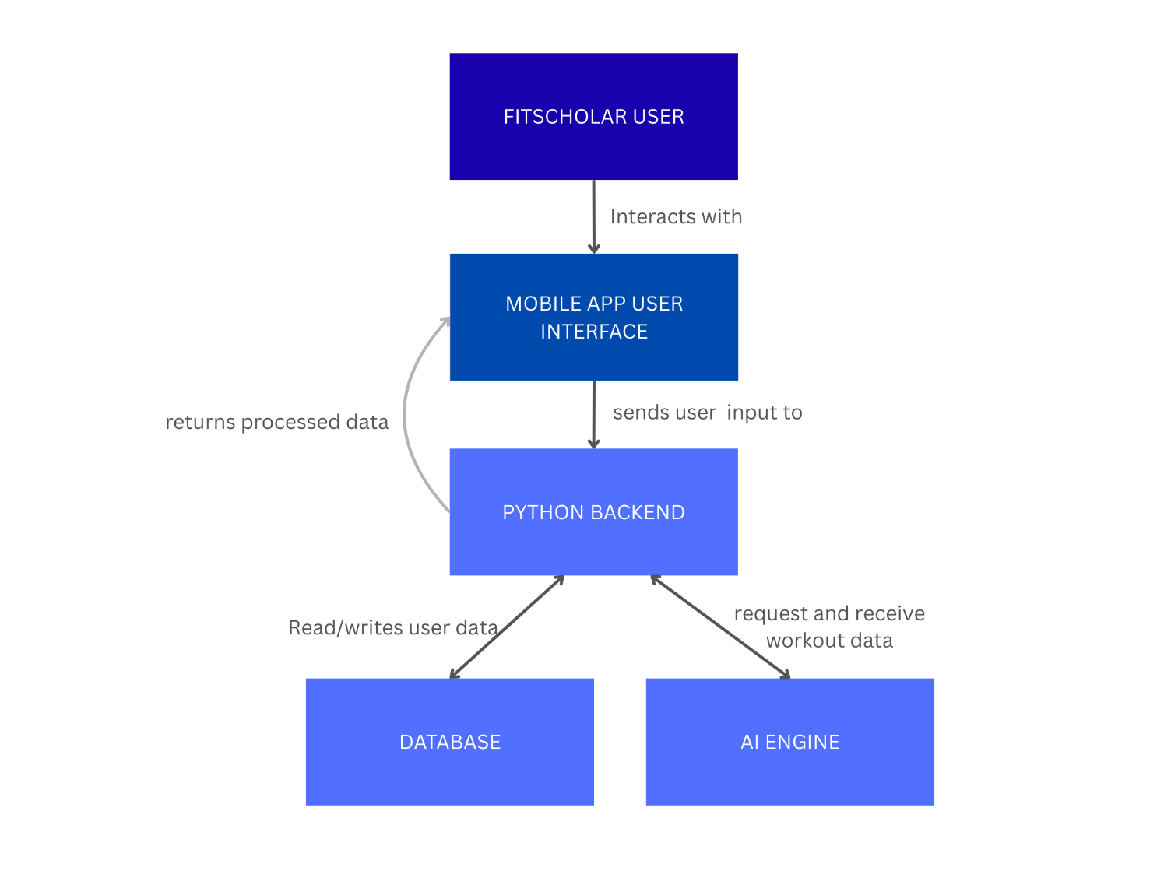

Data Flow Architecture
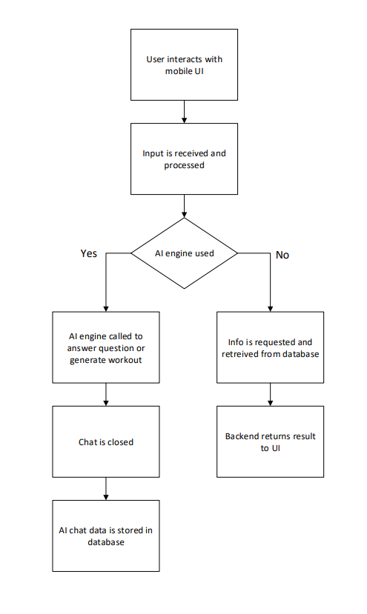

Component Description
Frontend (UI Layer)
The frontend will be responsible for presenting the user interface and handling user interactions. The frontend will be compiled using _ to create a seamless interface the users can easily interact with and view scheduling and workout plans, along with other dashboards within the app. The frontend will send input requests to the backend to be processed and will subsequently display what the backend returns.
Backend Layer
The backend will be primarily responsible for managing communication between the frontend, database, and AI engine. It will process commands and handle data logic to ensure smooth operability of the application. Our app will use Python-based backend code to support the different functions and tasks needed for the app.
Database Layer
The system’s database will store data including user profiles, workout history, feedback, and generated plans. The database layer will interact directly with the Python backend layer via commands.
AI Engine
The app will utilize OpenAI and machine learning libraries to consume user profile data, workout history, and feedback and generate personalized workout plans that adapt overtime. We chose this AI engine because of the ability to customize learning libraries and set refusal rules to better customize the end-user experience.

UML Class Diagram
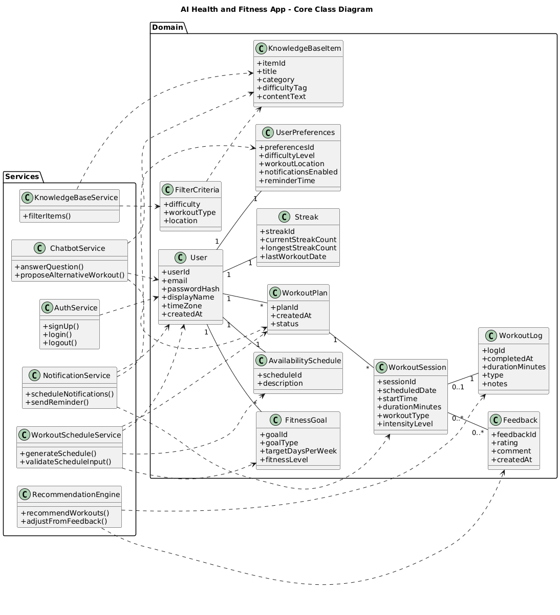

UML Class Diagram Explanation
This class diagram represents the overall object-oriented structure of the AI Health and Fitness App. It shows the main system components and how they interact to support the functional requirements defined in the Requirements Specification Document.
The diagram is divided into two main logical layers: Domain classes and Service classes.

Domain Layer
The Domain layer contains the core data objects that represent the main entities of the system. These classes model the real-world concepts described in the system overview, such as users, workout plans, workout sessions, logs, goals, and feedback
The User class is the central entity of the system. Each user has one set of preferences, one availability schedule, one streak record, and can have multiple fitness goals and workout plans. Each workout plan contains multiple workout sessions. Workout sessions may produce workout logs and feedback entries, which are later used by the AI recommendation logic.
The KnowledgeBaseItem and FilterCriteria classes support the knowledge base filtering feature defined in the functional requirements. These classes allow structured filtering of workout information based on difficulty, type, and location.
The relationships shown using solid lines represent structural associations between objects. These associations reflect how objects are connected in memory and how they will be stored in the database.
Service Layer
The Service layer contains the logic components responsible for implementing system behavior. These classes do not represent database tables but instead implement the functionality described in the use-cases and functional requirements.
- AuthService handles account creation and login functionality.
- WorkoutScheduleService generates workout plans based on user availability and fitness goals.
- RecommendationEngine adjusts workout recommendations using workout logs and feedback.
- ChatbotService supports AI-based workout guidance.
- KnowledgeBaseService filters and retrieves workout information.
- NotificationService manages reminders and scheduled notifications.
The dashed arrows represent dependencies. These indicate that a service class uses or depends on certain domain classes to perform its operations. For example, the RecommendationEngine depends on WorkoutLog and Feedback to generate adaptive recommendations.

ER Diagram
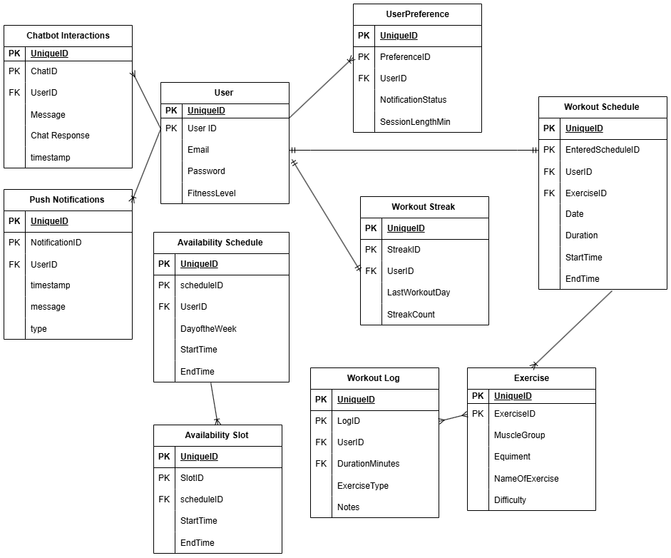
User entity is the main table, and it connects to most of the other tables in the system. One user can have many workout logs, workout schedules, availability schedules, push notifications, and chatbot interactions, so those relationships are one-to-many. Each workout log belongs to exactly one user, and each workout schedule also belongs to one user. The user also has one workout streak record, which makes that relationship one-to-one. The availability schedule can have multiple availability slots, so that is also a one-to-many relationship. Exercises are connected to workout schedules and workout logs, meaning one exercise can appear in many workouts, but each workout record references a specific exercise. Overall, the diagram shows that the user is the center of the system, and most other tables depend on the user through foreign keys, creating mostly one-to-many relationships throughout the database.

UI mock-ups
Upon opening the app, users are greeted with the app name and motto. Users are given the option to ‘Sign Up’ if they are not registered with us, or ‘Login’ if they are a returning user.
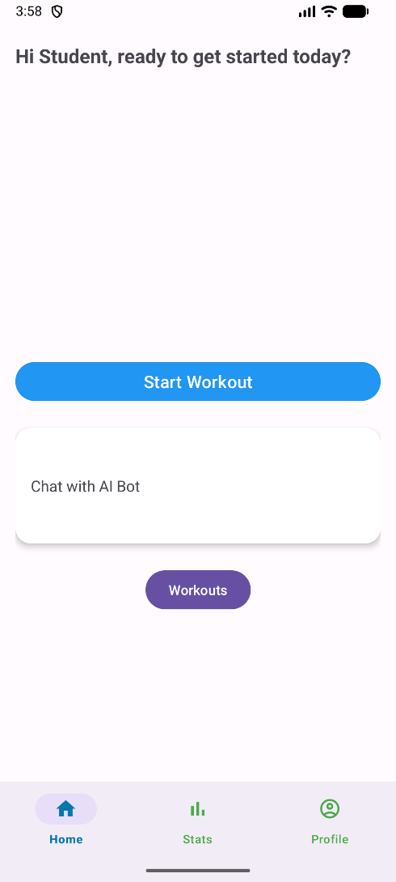
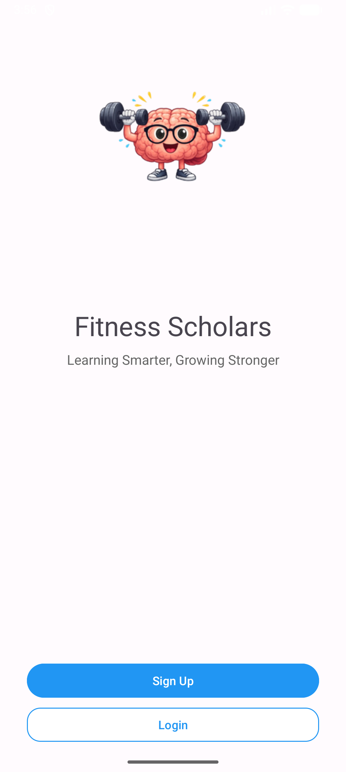
Figure 1 – Login Page Figure 2 – Home Screen

Figure 2 is the result of a user successfully logging into an account. This page will display a randomized greeting/motivational message for the user. A selectable option is the ‘Start Workout’ button which will take the user to a workout screen where they can select their personalized workout. The Home screen will also show a chat-box option where the user can chat with the AI bot and ask a variety of fitness-related questions. At the bottom of the page is a navigation bar allowing the user to conveniently travel to the different main screens, Home, Stats, and Profile.

Figure 3 displays the Stat page; this page will offer information on the user showing them their progress. It will show the user the number of workouts they have completed, their current consecutive workout streak, and their last workout information. At the bottom is the same navigation bar for easy navigation.

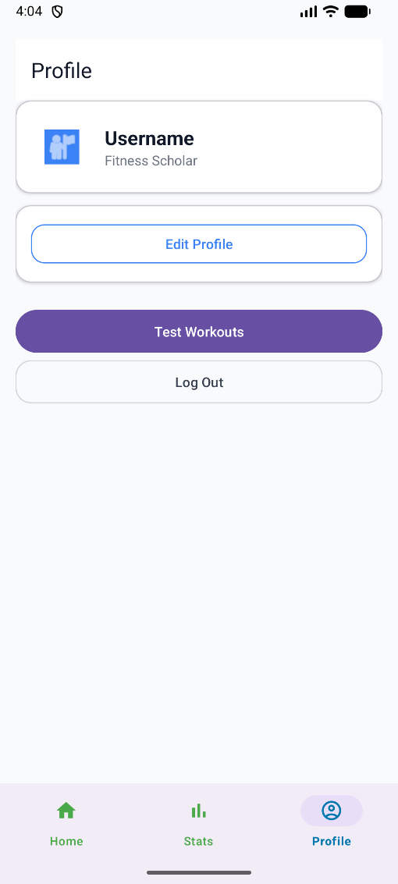
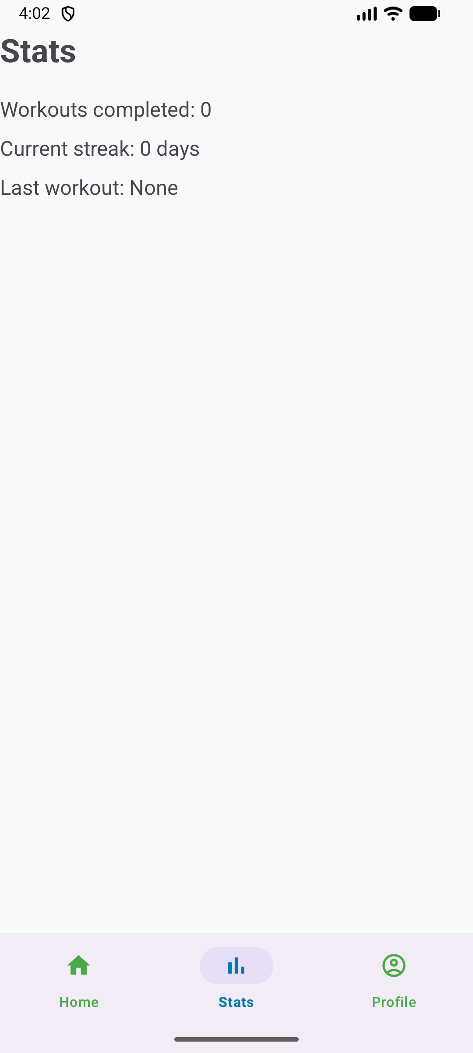
Figure 3 – Stats Page Figure 4 – Profile Page

Figure 4 shows the Profile page. This page will allow the user to adjust certain settings within the app. They can change their preferences and details, which will allow the app to give them tailored workout routines specifically made for their needs. There is also a log out button in case the user wishes to log out of the app.

Version Control Section
The version control is a critical component of the system design, as it creates coordinated development, change tracking, and safe integration of system components. Our project consists of the use of GitHub as the centralized version control system to manage our source code, documentation, and configuration of the files that will be implemented in our application by all our team members.

GitHub will serve as another method to communicate and coordinate our tools (code) for our system. Its repository is organized so the team can work on individual parts such as the frontend, backend, and documentation components. As we can leave README notes to describe how each branch of code works, such as the main branch that contains the front end (our Login.java, HomeScreen.java, LoginActivity.java, etc.), has the pull requests that provide visibility into ongoing development and issues that can be tracked as bugs or enhancement requests and commit messages document the purpose of each change.
This version control ensures that all the members on the team remain informed of any system changes and accountability and provides a reliable mechanism for recovering any previous versions in case any error(s) occur.

